The Eccles Train Crash
December 30th 1941

December 30th 2011 is the 70th anniversary of a serious accident that took place in 1941, during the Second World War, when two trains collided just outside Eccles Station, to the east between Eccles and Weaste. 23 people were killed and 105 injured. The violent collision took place when a train going eastwards into Manchester was crossing over from the slow to the fast line and was struck broadside by another train moving westwards down the slow line. The accident happened at 8.15 am, in deep fog and during the blackout. Both trains were crowded and in the cutting where the railway is sited, in the dark, the scene was horrendous and the rescue effort difficult and prolonged – the last passéngers were not freed until 1.30pm. The major rescue was mounted by medical, nursing and paramedical staff from Hope and Eccles & Patricroft Hospitals, first aiders, the Women’s Voluntary Service, railway rescue teams from across the area, passengers and members of the public. The inquiry took place immediately. It concluded that a combination of signalman and driver error, together with the conditions (fog and blackout), were to blame.

What happened and why
December 30th, 1941, was an ordinary wartime working day. As people went out, at 8.15am, it was foggy, dark and ‘raw’, but not frosty. ‘Blackout’, meaning that street, house and station lights were extinguished to prevent enemy bombers from recognising cities, factories and communication routes, did not end until 8.55am. Thick fog had begun the previous day and continued, making visibility appalling. Trains were running very late.

At Eccles station a crowd boarded the eastbound Kenyon to Manchester train, already 49 minutes late. Its movements were controlled by the signalman in the Eccles signal box : he decided to transfer it from the ‘slow up’ to the ‘fast up’ line, allowing it to overtake some trains ahead of it on the slow line. This meant the train would cross the ‘down slow’ line at a ‘crossover’.

To prevent collisions in poor visibility, ‘fogmen’ should have been at the three signals around the crossover. The scale diagram below illustrates this. But rules about duty times and reporting for work were complicated, and the signalling team was only 73% staffed. By 7am that day, the signalman thought the three fogmen had come on duty, but there were only two. The 6.53 train from Rochdale to Pennington, running down the ‘slow’ track from Manchester was travelling quite fast. It went straight through the first, ‘down slow distant’ signal where it should have stopped. At the second signal, the ‘down slow outer home’ - no fogman so no red light and no detonation. It reached the third signal -only 100 yards from the crossover – at about 30mph. The crash was inevitable. The heavy 8 carriage train and steam engine could not possibly stop in time. It ploughed into the Kenyon to Manchester train. A fuller account of the technical aspects of the accident will be found on the Freccles website Eccles Station News, January 2012 edition.

The Crash Scene and the Rescue:( Appleton, 1995)

‘The scene shortly after the crash was indescribable. In the pitiful light of the fires men were engaged in stripping coaches to get to those who were trapped. The splintered wood of the carriages was heaped into piles and set on fire to give the rescuers some light. The injured were being pulled out by the score, receiving first aid treatment on the ground. There was a steady stream of stretcher bearers along the platform and up the station steps to the ambulances which waited at the station approach. Hundreds of passengers who escaped with bruises and a shaking were standing amongst the wreckage. … A nearby house was converted into a rest centre for those who were badly shaken.

At the outset, pieces of the coaches were used as stretchers and splints. When the casualty service arrived they took control and the injured were quickly transferred to hospital. Many who were trapped underneath had to wait for special lifting devices and breakdown gangs from Patricroft sheds. Some of the trapped were dead.
Shouts of "Doctor here" were frequently heard amongst the din of creaking wood and the hissing of steam from the engine which had overturned. Doctors in white coats were administering morphia to the badly injured, whilst nurses in their uniforms were …. applying bandages and supplying stimulants.
It was well into the afternoon when rescue work was finally completed. One of the last to be released was a man who was located fairly early after the accident had occurred. He was trapped by the legs and in great pain ... The man was released after 4.1/2 hours.’ ² (He was, however, to die later of his injuries.)

‘Fine Rescue Work’
The rescuers were numerous; one of the few good things about the wartime context was that, because of the bombing of Manchester which had been at its worst in December the year before, many had been trained in rescuing casualties from difficult sites, and in first aid. There were many acts of bravery and courage. Doctors and nurses came from the two local hospitals, Hope Hospital (now Salford Royal) and Eccles and Patricroft Hospital (which was on Cromwell Road). Operations were performed on the spot until the ferrying of the casualties to the hospitals meant the staff had to return there to care for them. Night nurses from Hope came to the crash site straight from night duty – subsequently missing the Christmas Dinner which they should have been having at lunchtime on 30th December.

The Eccles Casualty Service, under the direction of the Medical Officer of Health, made good use of their training, the Eccles and Patricroft Journal reported, and the Women’s Voluntary Service ‘rendered valuable assistance’, as did the police, teams from the railways depots at Patricroft and Ordsall, a rescue team from Irlam steelworks, and ordinary members of the public.

The victims

Both trains were crowded. The one from Rochdale to Pennington, largely filled with men on their way to work; the Kenyon train, a mixture of men and women going to Manchester. Nineteen people died at the scene and four in the following days, 105 were injured, some seriously; the psychological impact on some was lifelong.

Eight women died : all young, aged between 16 and 25, and all in the train going towards Manchester. Amongst the dead was 21 year old Vera Davies, travelling with her twin Irene. Vera died ; Irene was badly injured. They were due to be bridesmaids for their sister’s wedding on New Year’s Day. A friend of the twins, 16 year old Joan Beeson was killed outright– probably all were in one compartment.

The men who died included workmen and employees of London, Midland and Scottish Railway Company, which ran the trains here. Two Longsight depot railmen, Jack Cresswell and Oswald Charles Johnson, both from Monton, were killed outright. (See box, ‘One Family’s Tragedy’). Many reported their experiences at the time and later.

From the Eccles & Patricoft Journal, January 2nd, 1942:
‘William Smith, of Mayfield Road, Eccles, …who escaped with a slightly-injured shoulder, paid tribute to the rescuers. “I had only just got sat down” he said “when I noticed that the door of the compartment had not been closed properly. I got up and eased it open in order to bang it to but as soon as I opened it the train shuddered and I was flung out on to the signal wires running alongside the line. Steam was hissing and people were shouting ‘Get me out.’ I ran back to the station…… I got a lamp and went back. A ladder was obtained and people were removed from a coach which was only slightly damaged. The large number of girls on the train behaved splendidly. One doctor in a white coat worked like a trojan to alleviate the pain of the injured and a lady doctor, also in a white coat, did wonderful work in putting splints on broken limbs. A nurse repeatedly went under a wrecked coach to tend to a young man who was trapped. All the doctors and the casualty service personnel worked wonders and did everything humanly possible to attend to the injured under the conditions.”

‘Joan Roberts (15) of Eccles boarded at Eccles and got into the last coach. The train had not moved many yards when she felt a bump and nearly fell to the floor…… She ran along the platform towards the engine and immediately helped with the rescue work. With a senior first aid man, Albert Burns, she crawled under wrecked coaches, bandaging the injured and securing broken limbs…. It was not until about two hours later that she returned home. Joan is a member of the Women’s Junior Air Corps and it was only recently that she gained her badge and certificate for practical knowledge in first aid.’

One Family’s Tragedy
One of those killed was Jack Cresswell, of Highfield Drive, Monton. Jack was a senior employee of the London, Midland & Scottish Railway, an Assistant District Locomotive Superintendant, travelling to Manchester to work at Longsight depot. His death had an impact on many people: two of his sons, Bert (87) and Peter (79) have vivid memories of that time and what followed.
Bert, 17 in 1941, was working in Salford when a driver told him there had been a serious train crash at 8.15am. Bert immediately knew his father would be on that train. He ran all the way back to Eccles, first to the station where he looked over the wall and down the steps at the station, but could see nothing, so thick was the fog. He ran back home, his Mother did not even know of the accident. ‘We started ringing the hospitals, but no joy. Eventually we phoned the police, they said “He’s marked dead.” The phrase sticks in my mind still. I had to break the news to Mother, widowed at 44 with four children.’

Peter, only 8, was not told directly of what had happened but realised his father had died. When the funeral took place, he was sent to the back room of a neighbour – funerals were no place for children, in the 1940s – ‘I had to piece it together for myself’. But Peter also remembers the sadness and worries afterwards – his mother’s grief; her anxieties for the eldest son, also called Jack, in the RAF as aircrew; for Bert who went in to the Navy and was escorting transatlantic shipping (both incredibly risky jobs), as she struggled to look after Peter (in poor health, then) and the fourth brother Dennis (12). There were many tears.

Managing was made harder by shortness of money. Mrs Cresswell went to court, with the widow of another LMS employee killed in the crash, Mrs Johnson, for the compensation which the family were to live on – it was ‘peanuts’, Bert remembers. The judge’s words were harsh ‘You’re a very attractive lady – I’ll pay it in instalments.’ (In other words, - he expected to her remarry and the payments could then be stopped.) Such attitudes made the difficulties harder to bear.

An extra twist in this sad story is that Jack Cresswell’s job had previously been based at Patricroft engine depot – and it was the workmen from Patricoft who found his body on the track.

Why did it happen?

The inquiry and the aftermath

An inquiry was set up immediately after the scene had been inspected by the London Midland and Scottish Railway company and the Ministry of War Transport. It was held by Major GRS Wilson, a Ministry Inspector. It opened on January 7th 1942 at the Cross Keys Hotel, Eccles, reporting in April. Amongst those giving evidence were both driver and fireman of the Rochdale to Pennington train, coming from their hospital beds. The driver and fireman of the Kenyon to Manchester train were not injured physically, but it is said the impact of the crash on the driver was traumatic and he could not work afterwards. Some evidence was given in camera, to allow the men to speak freely. The aim of this inquiry was ‘primarily from the technical aspect of the case in order that the Minister of War Transport could be fully advised of the cause of the accident and of any measures it might be desirable to adopt in the interests of public safety to prevent a recurrence.’ (ie Not an inquiry to determine legal responsibilities : Eccles&Patricroft Journal,9 Jan 1942.) The conclusion was that the primary causes were mistakes by the signaller and the Rochdale train driver, with fog as a secondary cause. The lack of full staffing was noted, but was not seen as unusual.

The report made recommendations to improve signalling arrangements to prevent accidents in future. When one reviews the tragedy and the reports today, it seems clear that the accident was the result of a combination of system weaknesses with human failures, compounded by the weather and war conditions.

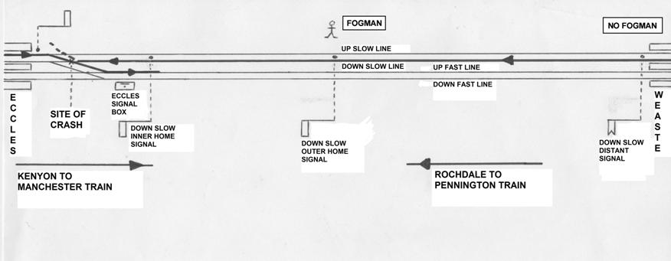
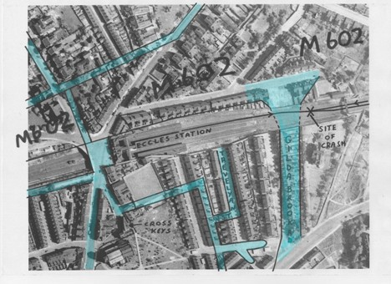

This poster has been created by members of Freccles, with help from relatives of one crash victim, contemporary newspapers, Salford Local History Museum and other sources including :
CA Appleton: A Serious Accident at Eccles :Eccles Historical Society Journal, 1995
London, Midland & Scottish Railway Inquiry Report, 9th April 1942; Maj GRS Wilson

